**Task-4**

**Implement a custom aggregation function for use with `groupby` in pandas.**

1. **Task** **Description:**

* The goal of this task is to create a custom aggregation function and apply it to a Pandas DataFrame using the groupby method. This custom function will be used to calculate a specific statistic or metric for each group in the DataFrame. By the end of this task, a grouped DataFrame with custom metrics computed per group.

1. **Task Output Screenshot:**

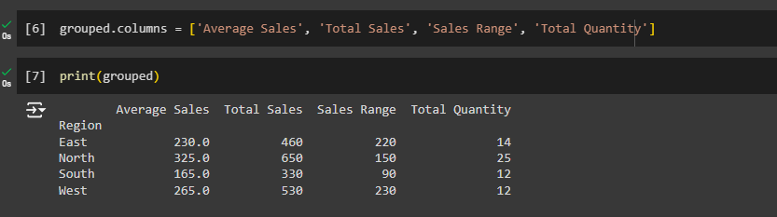

1. **Algorithm Used In Task**

* Create a sample DataFrame.
* Define a custom aggregation function.
* Apply the custom function with groupby().
* Average Sales: The average sales for each region.
* Total Sales: The total sales for each region.
* Sales Range: The difference between the highest and lowest sales values for each region.
* Total Quantity: The sum of quantities sold for each region.